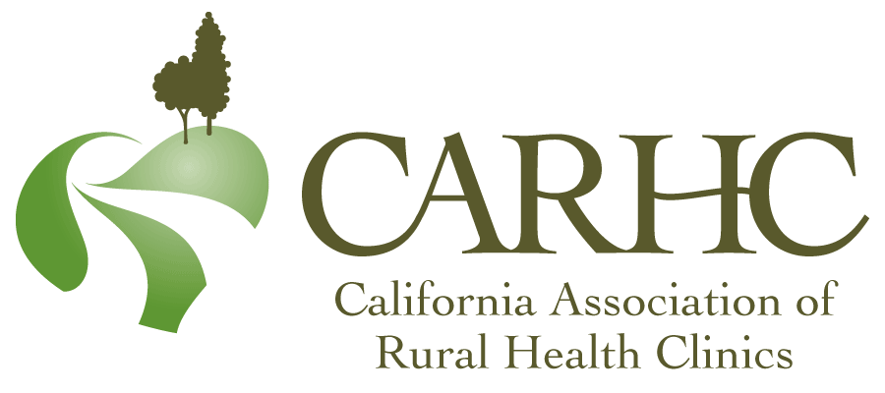
MEMBERSHIP APPLICATION
ORGANIZATIONAL MEMBER INFORMATION
(Please complete a separate form for each clinic.)
Membership category (Please indicate) |  |  |  | - CARHC clinic membership |  |  | - Affiliate  non-clinic membership
Clinic Name:
Name of Health System or District Affiliation (if applicable):
Name of Hospital or Organization (if applicable):
Clinic or Organization | Physical Street Address:
 | City: |  |  | State: | ZIP Code: |  |  | County:
 | Phone: |  |  | Fax: | Email: |  |  | Website:
 | Mailing Address (if different):
 | City: |  |  | State: | ZIP Code: |  |  | Clinic CMS Number:
 | RHC category (Please check) |  |  | - Independent |  | - Provider-Based |  |  | - Affiliate
 | Ownership category (Please check) |  |  | - Nonprofit |  | - For Profit-Corporation |  |  | - Government-Federal
 |  |  |  |  |  | - For Profit-Partnership |  |  | - Government-Local
 |  |  |  |  |  | - For Profit-Individual
Clinics Only: |  |  | Annual RHC Encounters: |  | RHC Certification Year: |  |  | # RHC Employees (Not FTE):
Affiliates: Please provide information about your interest in RHCs. (This may be used in your directory listing.)
Member Contacts: Name(s), Emails, and Direct Phone Number. (We encourage multiple contacts in your organization.) (Please indicate the primary contact and billing contact.)
ANNUAL DUES
$300 |  | CARHC Member Clinic
$100 |  | Additional clinic Membership (Please complete a separate Membership Application for each additional member, additional clinics must be within the same health system)
$350 |  | Affiliates (Non-Clinic Member)
Please mail your application and payment to CARHC, 5817 N. Maruyama, Fresno, CA 93723.
If you have any questions, call us at 559-706-8226 or email to Info@CARHC.org.
SIGNATURE
Signature of applicant: |  |  |  |  |  |  |  | Date:
www.CARHC.org Version 13, 01/11/22

